ITT-216- Limiting VLANS

Professor: Tim Collins
Course: ITT-216 Enterprise Route & Switch
Student: Liela Pressley
Date: 4/11/2023
Title: Limiting VLANs

Admin Workstation successfully showing DHCP support using ipconfig /release and ipconfig /renew and successfully pingin the DHCP server ip address: 10.10.42.88.
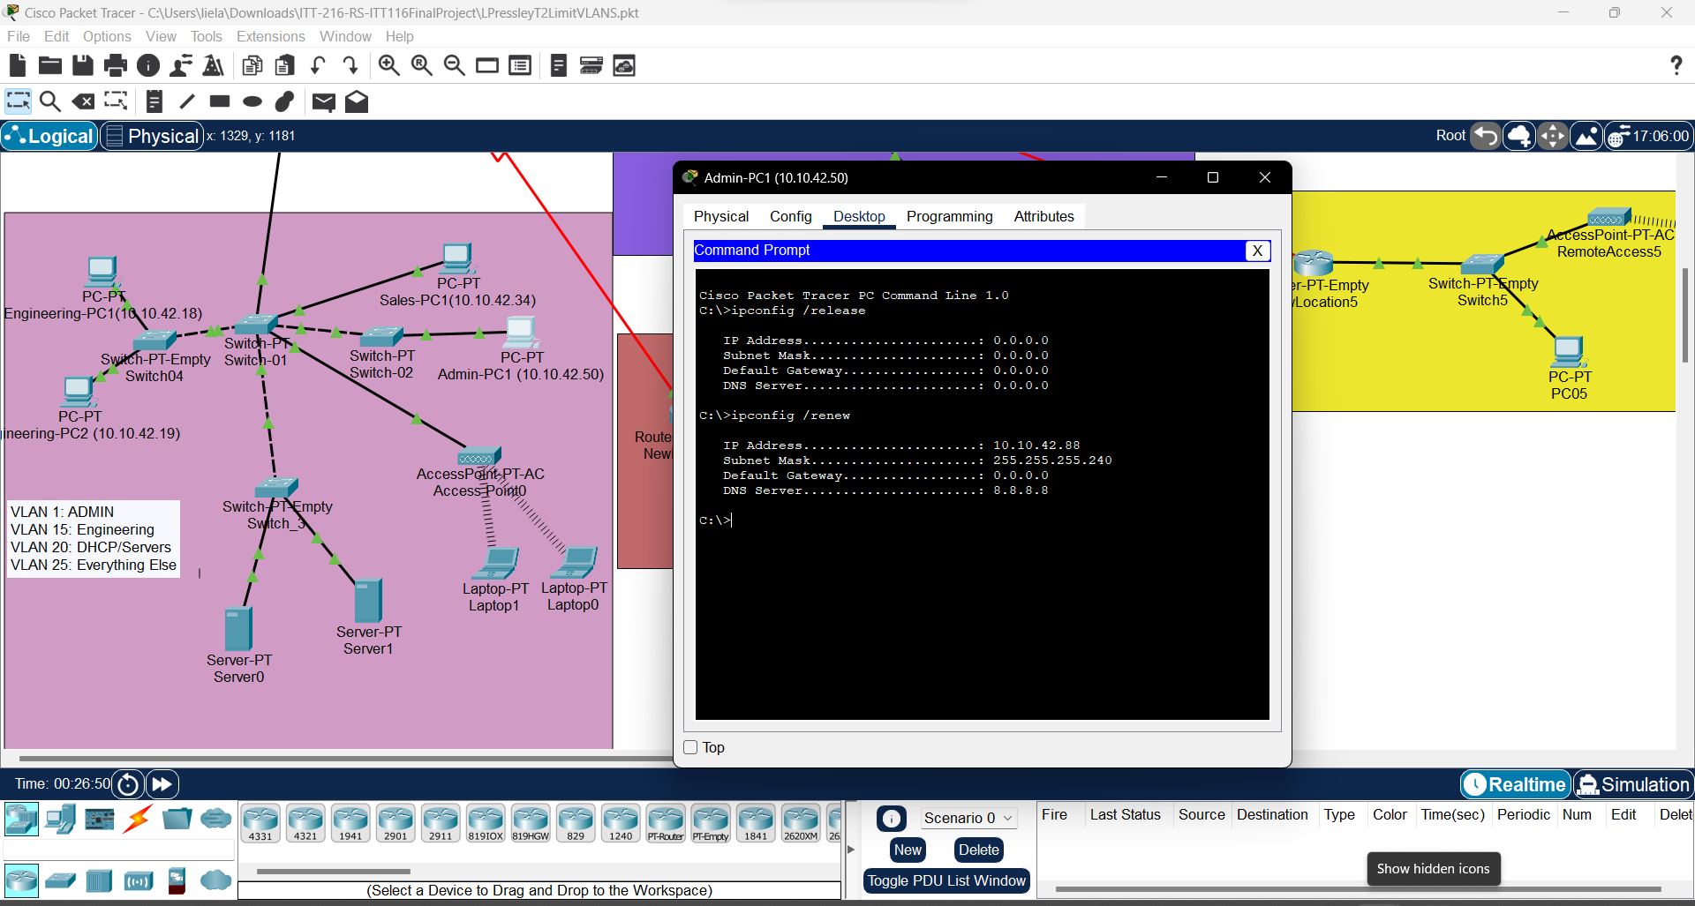

Successfully pinging DHCP server from admin workstation via vlan 20 through the switches.
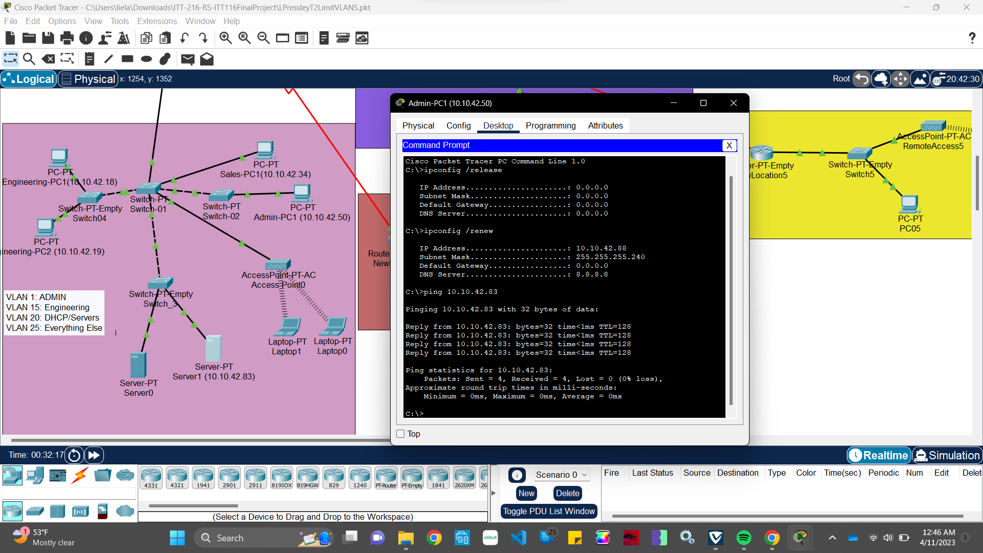
Failed ping from Engineering workstation on VLAN 15 to DHCP server
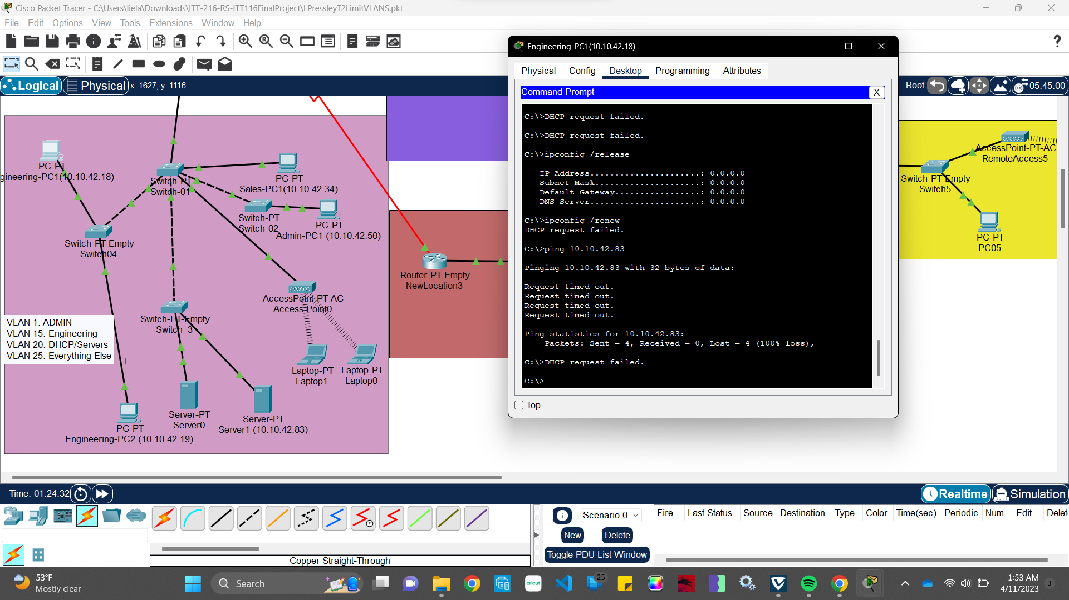
Successful ping from 2nd Engineering Workstation to DHCP Server followed by failures after tinkering with the switches more probably breaking the connection again. 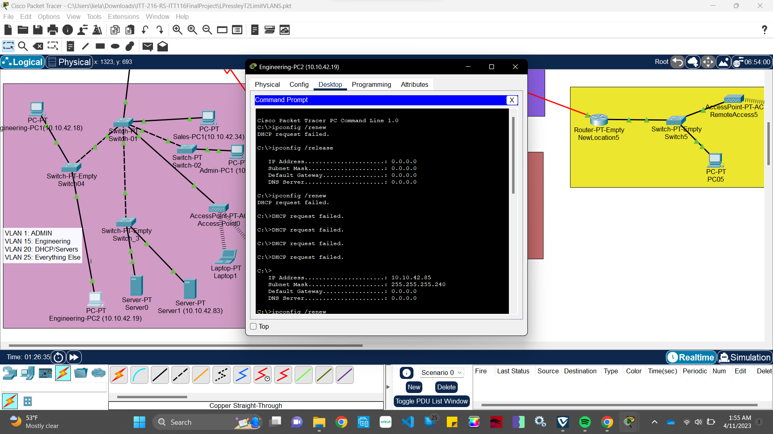
After restarting the project I was able to successfully create each VLAN and ping engineering PC to the DHCP server. Shown Below.

………………………………………………………………………………………………………
